-- SQL PROJECT

use priya;

select * from olympics;

-- 1. Show how many medal counts present for entire data

select medal , count(Medal) as Medal_No from olympics group by medal order by Medal_No asc;

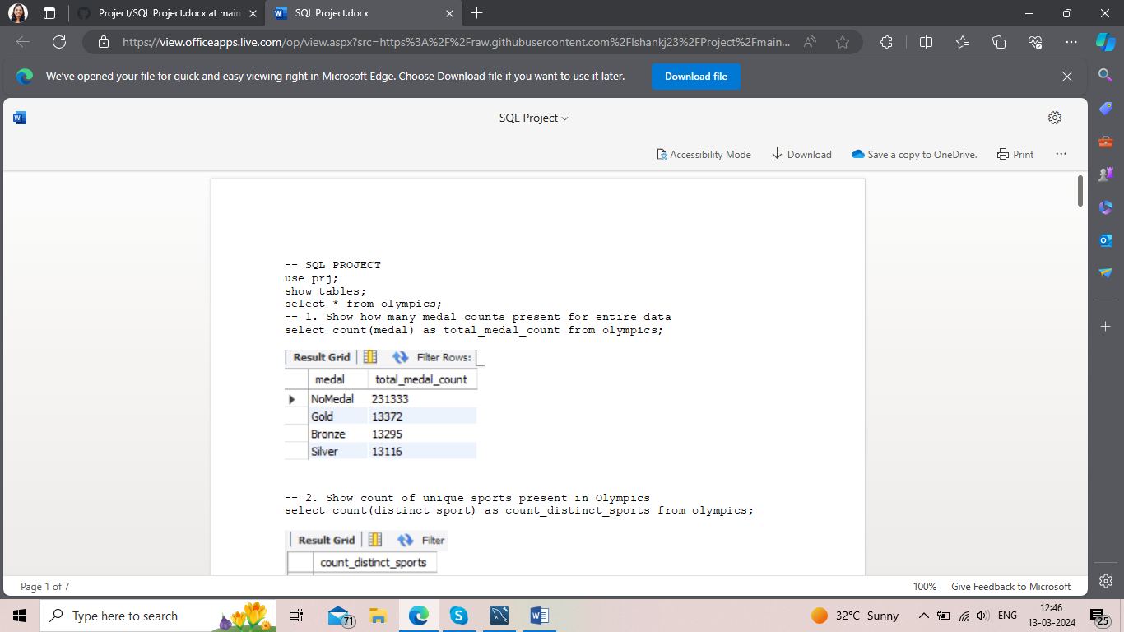

-- 2. Show count of unique sports present in Olympics

select count(distinct Sport) as Total_Sport from olympics ;

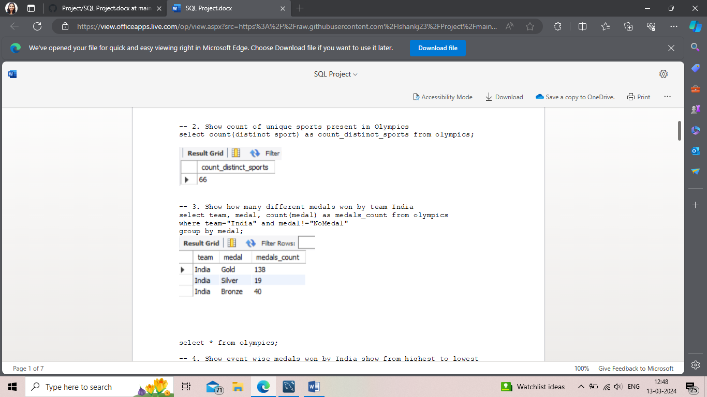

-- 3. Show how many different medals won by team India

select Medal , count(Medal) as Medal_Won from olympics where Team = 'India' group by Medal having medal!='NoMedal' order by Medal_Won asc;



-- 4. Show event wise medals won by India show from highest to lowest medals won in order

select Event ,count(Medal) as eve from olympics where Team='India' and medal!='NoMedal' group by Event order by eve desc;

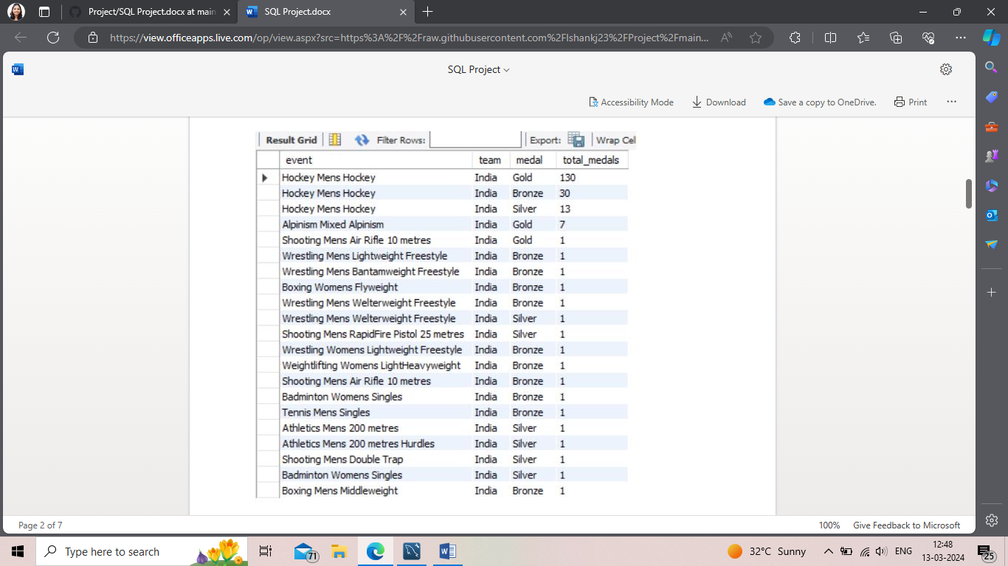

-- 5. Show event wise medals won by India in order of year

select Year , Event,count( Medal) from olympics where team='India' and medal!='NoMedal' group by Event,Year order by Year desc;

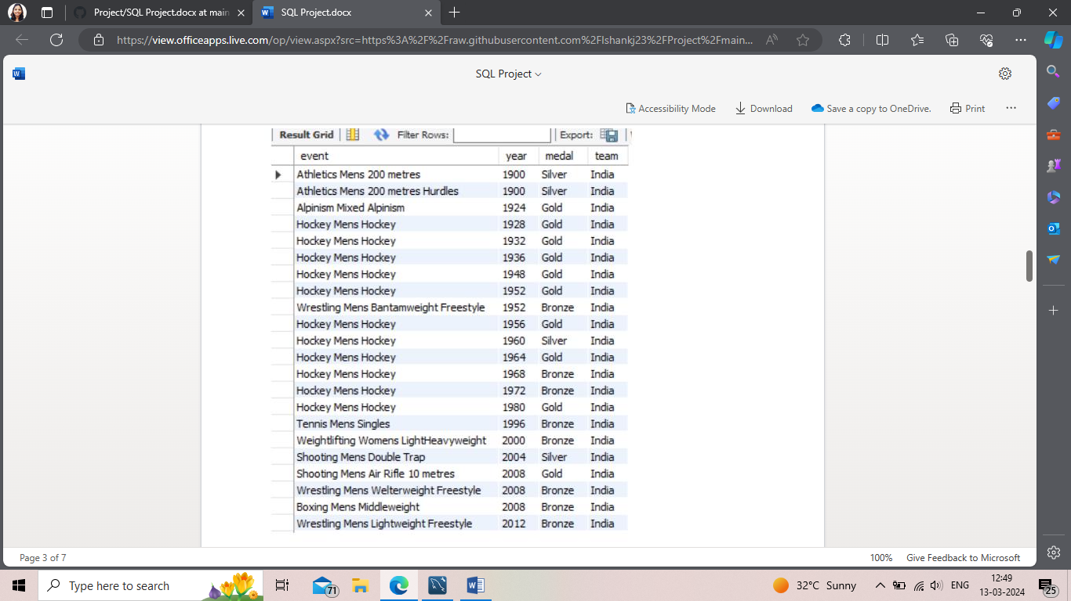

-- 6. show country who won maximum medals.

select Team ,count(Medal) as cnt from olympics where Medal!='NoMedal' group by Team order by cnt desc limit 1;

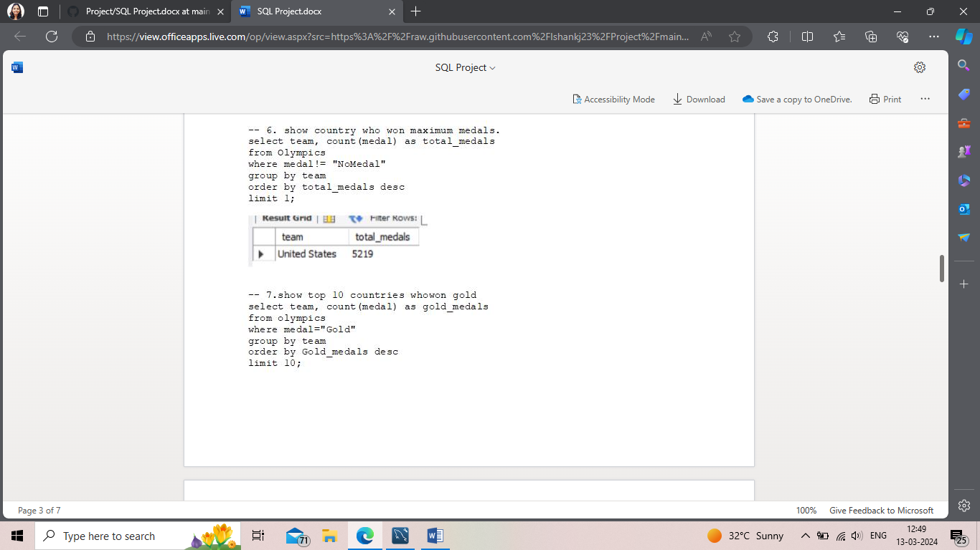

-- 7.show top 10 countries who won gold

select Team ,count(Medal) as cnt from olympics where Medal='Gold' group by Team order by cnt desc limit 10;

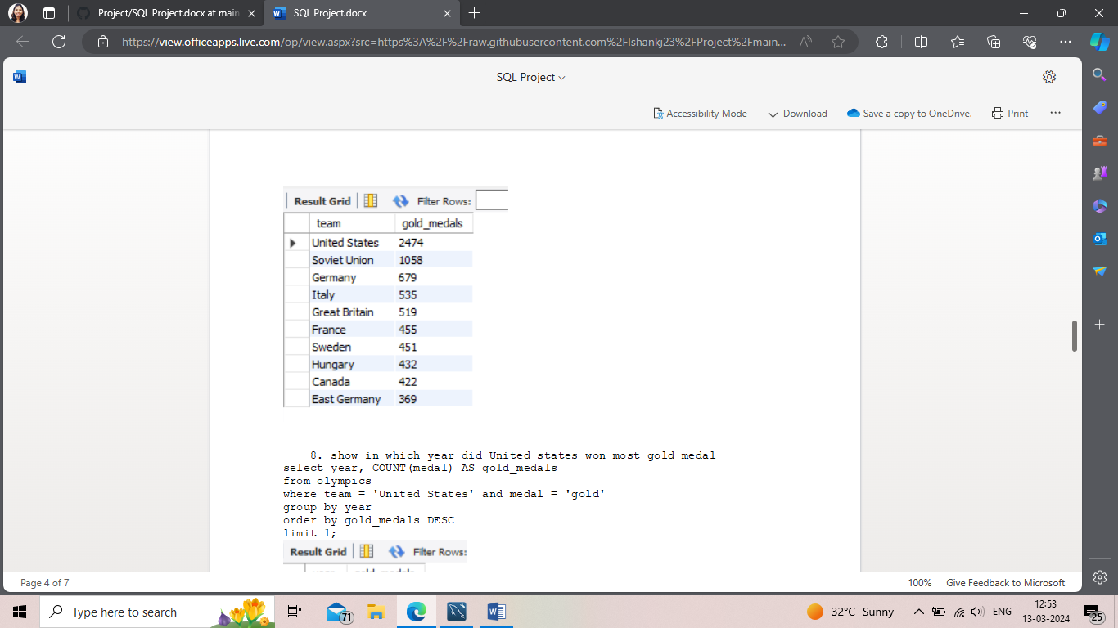

-- 8. show in which year did United states won most gold medal

select count(Medal),Year from olympics where Medal='Gold' and Team = 'United States' group by year order by count(Medal) desc limit 1;

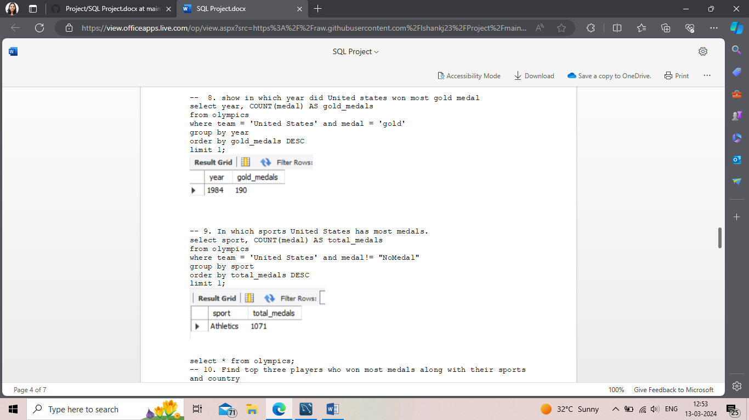

-- 9. In which sports United States has most medals.

select Sport, count(Medal) from olympics where Team='United States' and Medal!='NoMedal' group by Sport order by count(Medal) desc limit 1;



-- 10. Find top three players who won most medals along with their sports and country

select Name ,Sport,Team, count(Medal) as cnt from olympics where medal!='NoMedal' group by Name,Sport,Team order by cnt desc limit 3;

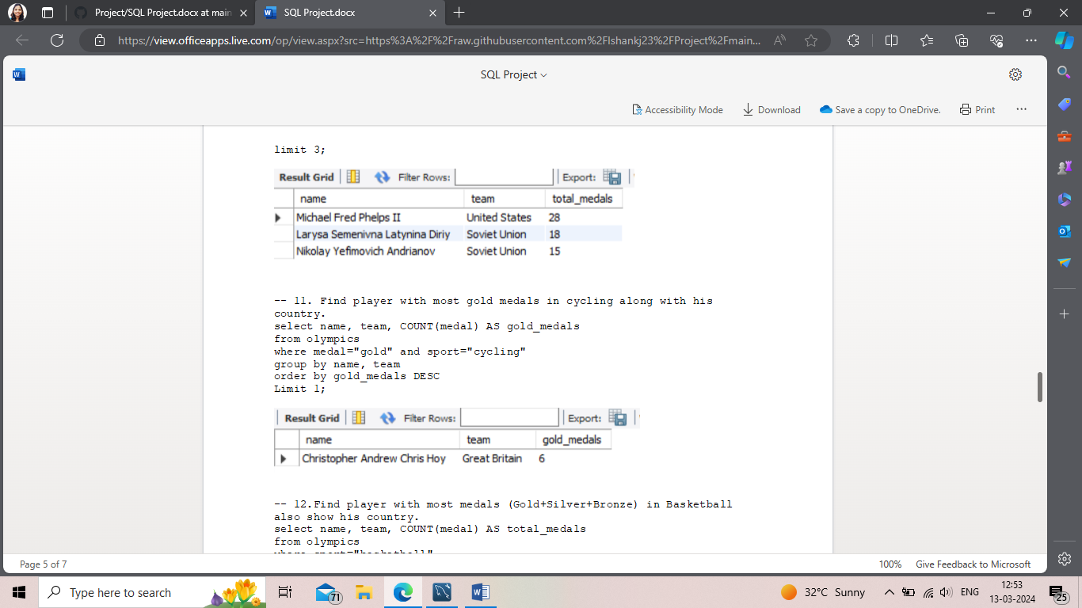

-- 11. Find player with most gold medals in cycling along with his country.

select Name,Sport,count(Medal) from olympics where medal='Gold' and Sport='Cycling' group by Name order by count(Medal) desc limit 1;



-- 12.Find player with most medals (Gold+Silver+Bronze) in Basketball also show his country.

select Name,Team,Sport,count(Medal) from olympics where medal!='NoMedal' and Sport='Basketball' group by Name,Team order by count(Medal) desc limit 1;

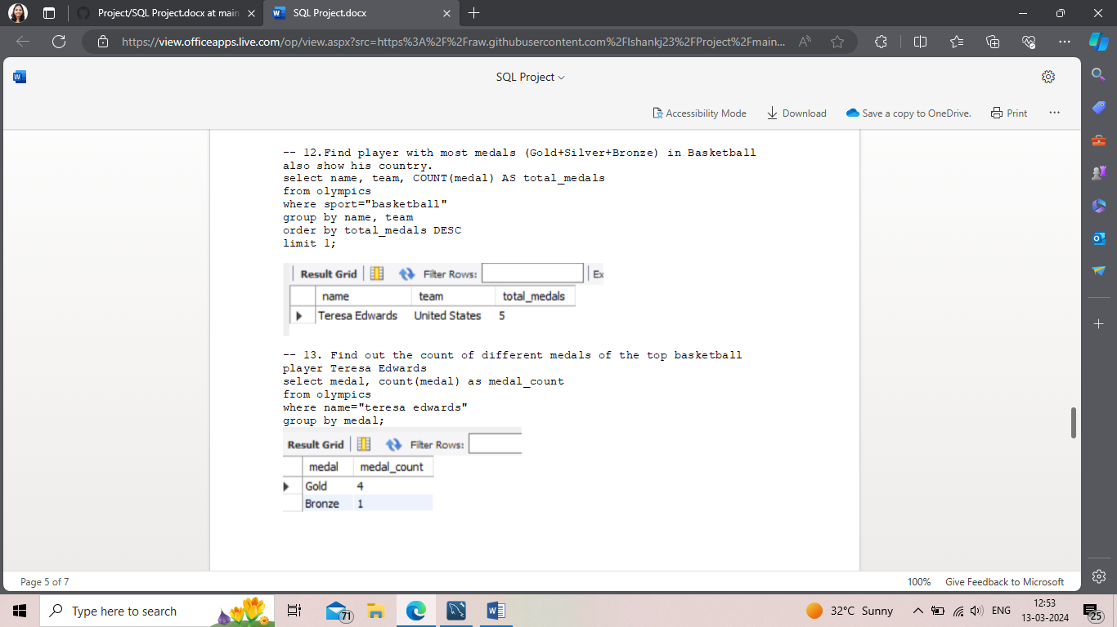

-- 13. Find out the count of different medals of the top basketball player Teresa Edwards

select Name,Medal,count(Medal) from olympics where Name='Teresa Edwards' group by medal;



-- 14. Find out medals won by male,female each year , Export this data and plot graph in excel

select Sex,Year,count(Medal) from olympics group by Sex,Year order by Year desc;

